Is Feature Scaling required for the K means Algorithm?

What is the Objective Function of k-Means?
- What are the steps for K-Means Algorithm
- What are the steps followed for implementing KMeans in python?
- What are some applications of KMeans Clustering?
- What are the steps to form clusters in KMeans Clustering?
- What are the limitations of KMeans Clustering?

Solutions:

- Yes, K-Means typically needs to have some form of normalization done on the datasets to work properly since it is sensitive to both the mean and variance of the datasets.For performing feature scaling, generally, StandardScaler is recommended, but depending on the specific use cases, other techniques might be more suitable as well.
- The objective of K-Means clustering is to minimize total intra-cluster variance, or, distance function. The objective function of k-means depends on the proximities of the data points to the cluster centroids. It is shown below:
Where is the weight of x, n_{k} is the number of data objects assigned to cluster C_{k}
is the centroid of cluster k is the number of clusters set by the user. The function dist computes the distance between object x and centroid m_{k, 1≤k≤K.}

While the selection of distance function is optional, the squared Euclidean distance, i.e. ∣x−m∣²
has been most widely used in both research and practice.
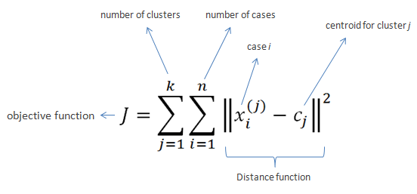

Steps followed by K-Means Algorithm
- The first step in this model is to specify the K value.
- Based on this K value, the dataset is partitioned into initial clusters.
- Random centroids are assigned to the dataset from the initial K values which will be away from the original observations.
- Then the model calculates distances from every observation in the cluster to the random centroid. Where the distance value is less and nearer to the random centroid, every observation gets mapped to the centroid. Like this, for all the observations in the dataset, the values are calculated and the observations are assigned suitably. The Euclidean distance metric is the default measure to calculate all distance from the centroid to the observations.
- Once the distances are calculated, random clusters are formed.
- Based on these random clusters, an iterative process of assigning new centroids enables the formation of new clusters. Here the variance is calculated to every observation in the cluster from the centroid.

Steps followed in Python

1.Data Collection and Import Libraries
2.Data Handling

3.Data Pre-processing

4.Modelling and Performance Measure
5.Cluster Profiling

- K-Means clustering is used in a variety of examples or business cases in real life, like:
- Academic performance
- Diagnostic systems
- Search engines
- Wireless sensor networks
- The steps to form clusters are:
Step 1: Choose K random points as cluster centers called centroids.
Step 2: Assign each x(i) to the closest cluster by implementing euclidean distance (i.e., calculating its distance to each centroid)
Step 3: Identify new centroids by taking the average of the assigned points.
Step 4: Keep repeating step 2 and step 3 until convergence is achieved
- A. This algorithm is computationally expensive and requires time proportional to the product of the number of data items(n), number of clusters (k), and the number of iterations (m).
B. It generally converges to a local optimum because the quality of the resulting clusters highly depends on the selection of the initial k clusters.
C. It can suffer from an empty cluster problem.

